DRUIM NAN SLOCHD
Flodigarry, Isle of Skye

ARCHAEOLOGICAL WATCHING BRIEF

JULY 1999

Erection of Telephone Relay Mast and Generator Cabin

by

Martin Wildgoose

for

British Telecommunications PLC
CONTENTS

Fig. 1 Location

Summary

The watching Brief

Report

Fig. 2 Foundations for the generator shed : plan and section

Fig. 3 Schematic location plan : location of generator shed and mast

Location of records

Slide index

Appendix A Specification for Archaeological Watching Brief

Appendix B SMR Cards for - Dun : Druim nan Slochd NG 47SE 7

Flodigarry Broch NG 47SE 6

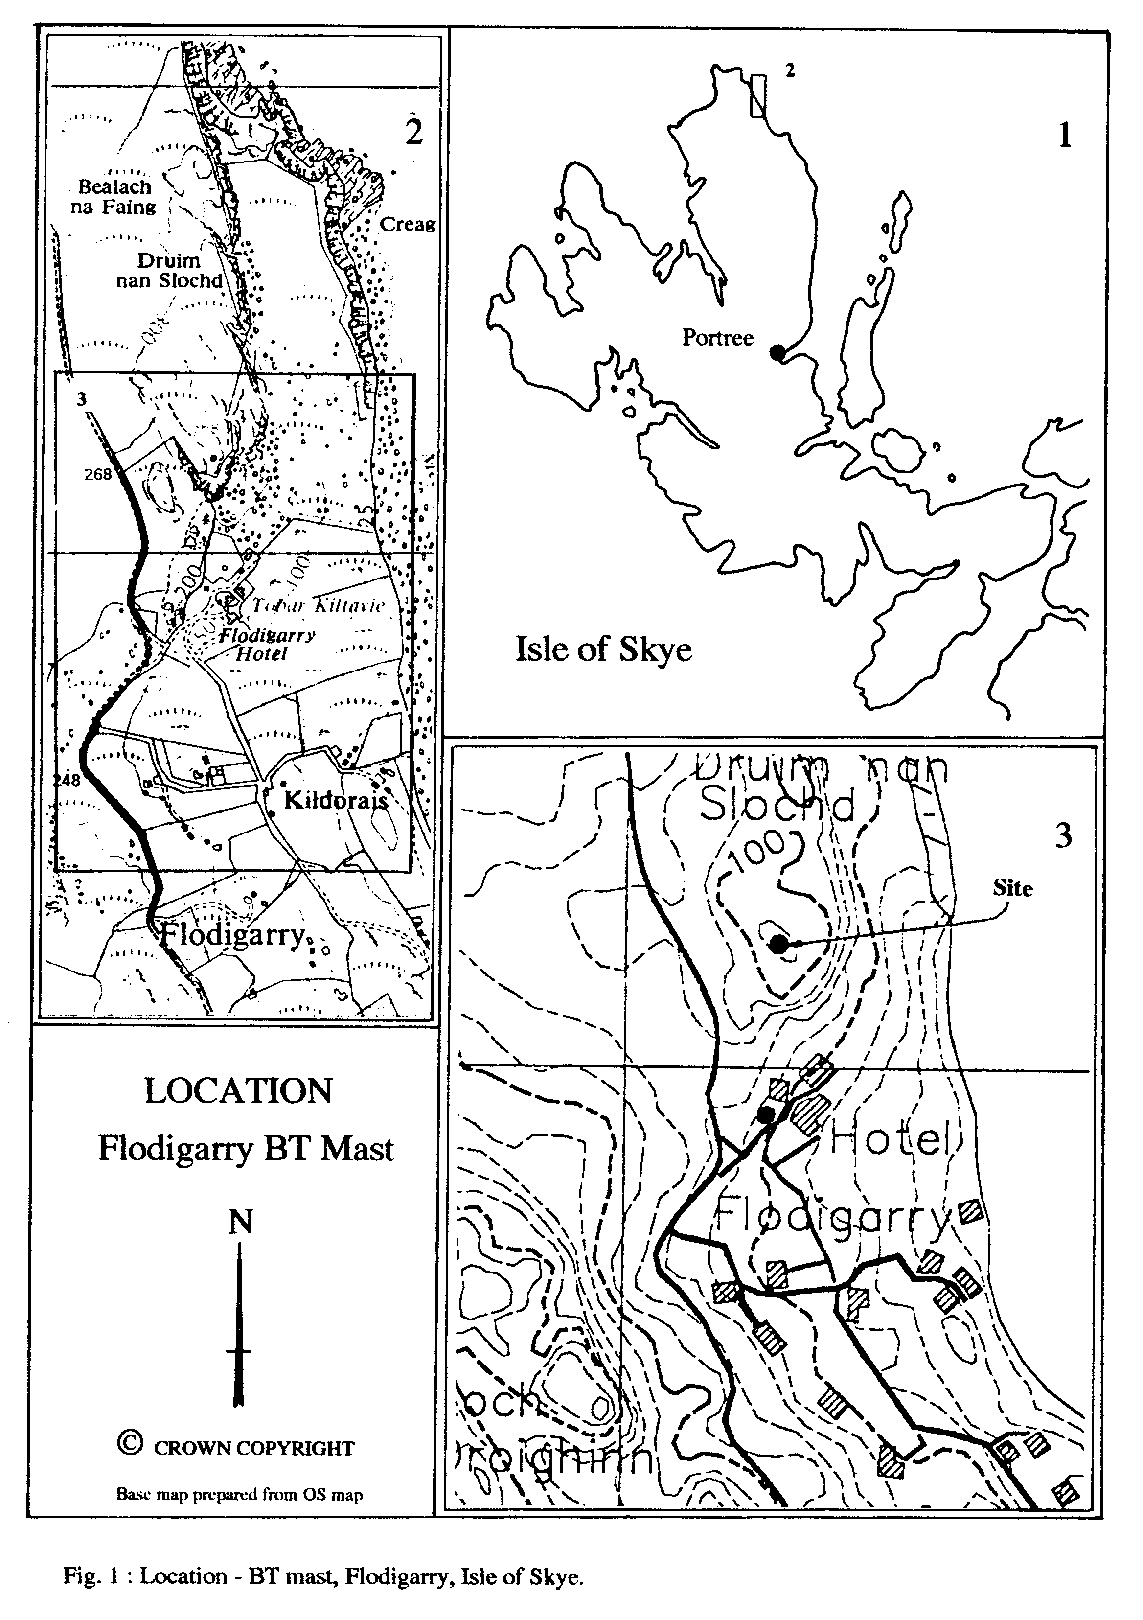

DRUIM NAN SLOCHD. Trotternish Parish, Isle of Skye. NG 464722

A watching brief carried out during the excavation of the foundations for a BT telephone relay mast and associated generator shed.

SUMMARY

The site of the proposed works lies on the summit of Druim nan Slochd, at a height of 120 metres above OD and approximately 350 metres to the north of the Flodigarry Hotel. A previously recorded Dun (NG 47SE 7) and the remains of Flodigarry Broch (NG 47SE 6) lie 70 and 100 metres respectively to the south of the proposed site. The proposed site works affected neither structure. (See Appendix B for the SMR cards for these sites)

The excavations and watching brief was carried out on the 29th July 1999 during a spell of fine sunny weather. Two sites were excavated – the foundations for the generator shed and the socket for the relay mast. The excavations were carried out by a tracked excavator with a toothless bucket. No archaeological levels were encountered.

WATCHING BRIEF

The foundations for the generator shed were excavated first :- ( SEE Fig. 2)

A 6.00 metre by 4.00 metre trench, aligned north-west to south-east, was excavated to a depth of 300mm revealing a uniform layer of fibrous peat over the entire trench. A 1.00 metre wide trench was then excavated, within the perimeter of the trench, to a depth of 200mm - still within the peat layer. Six circular shafts were then dug to a depth of 500mm, 3 on each long axis, within the 1 metre trench giving a total depth of 1.00 metre. The bottom 250mm of the circular shafts cut into a layer of fine grained, grey clay, The fibrous peat lay directly upon the clay.

A 1.00 metre square trench was excavated for the relay mast, 30.00 metres to the north-east of the generator shed, to a depth of 1.50 metres. A similar series of sub-strata was encountered.

REPORT

Generator Shed Trench 6.00 metres by 4.00 metres to a total depth of 1.00 metre.

The excavations cut through a 750mm thick layer of fibrous peat and 250mm into a layer of fine grained, grey clay.

At no point were archaeological deposits encountered.

Relay mast Trench 1.00 Metre Square to a total depth of 1.50 metres

The excavations cut through a 500mm layer of fibrous peat which lay directly on a grey to orange clay. The clay became inter-mixed with a small, sharp ratchel stone towards the limit of the section.

At no point were archaeological deposits encountered.

Upon completion of the excavation and watching brief the trenches were shuttered and filled with concrete to a level just above the present ground surface.

LOCATION OF RECORDS

All records and site drawings are held in the archive of M. Wildgoose

Tigh an Dun
Dunan
Broadford
Isle of Skye IV49 9AJ

Retained drawings include: -

Site drawing on drafting film of the generator shed excavation - plan and section.
Architects drawings of the site proposals.
Written notes relating to the site visit and watching brief.

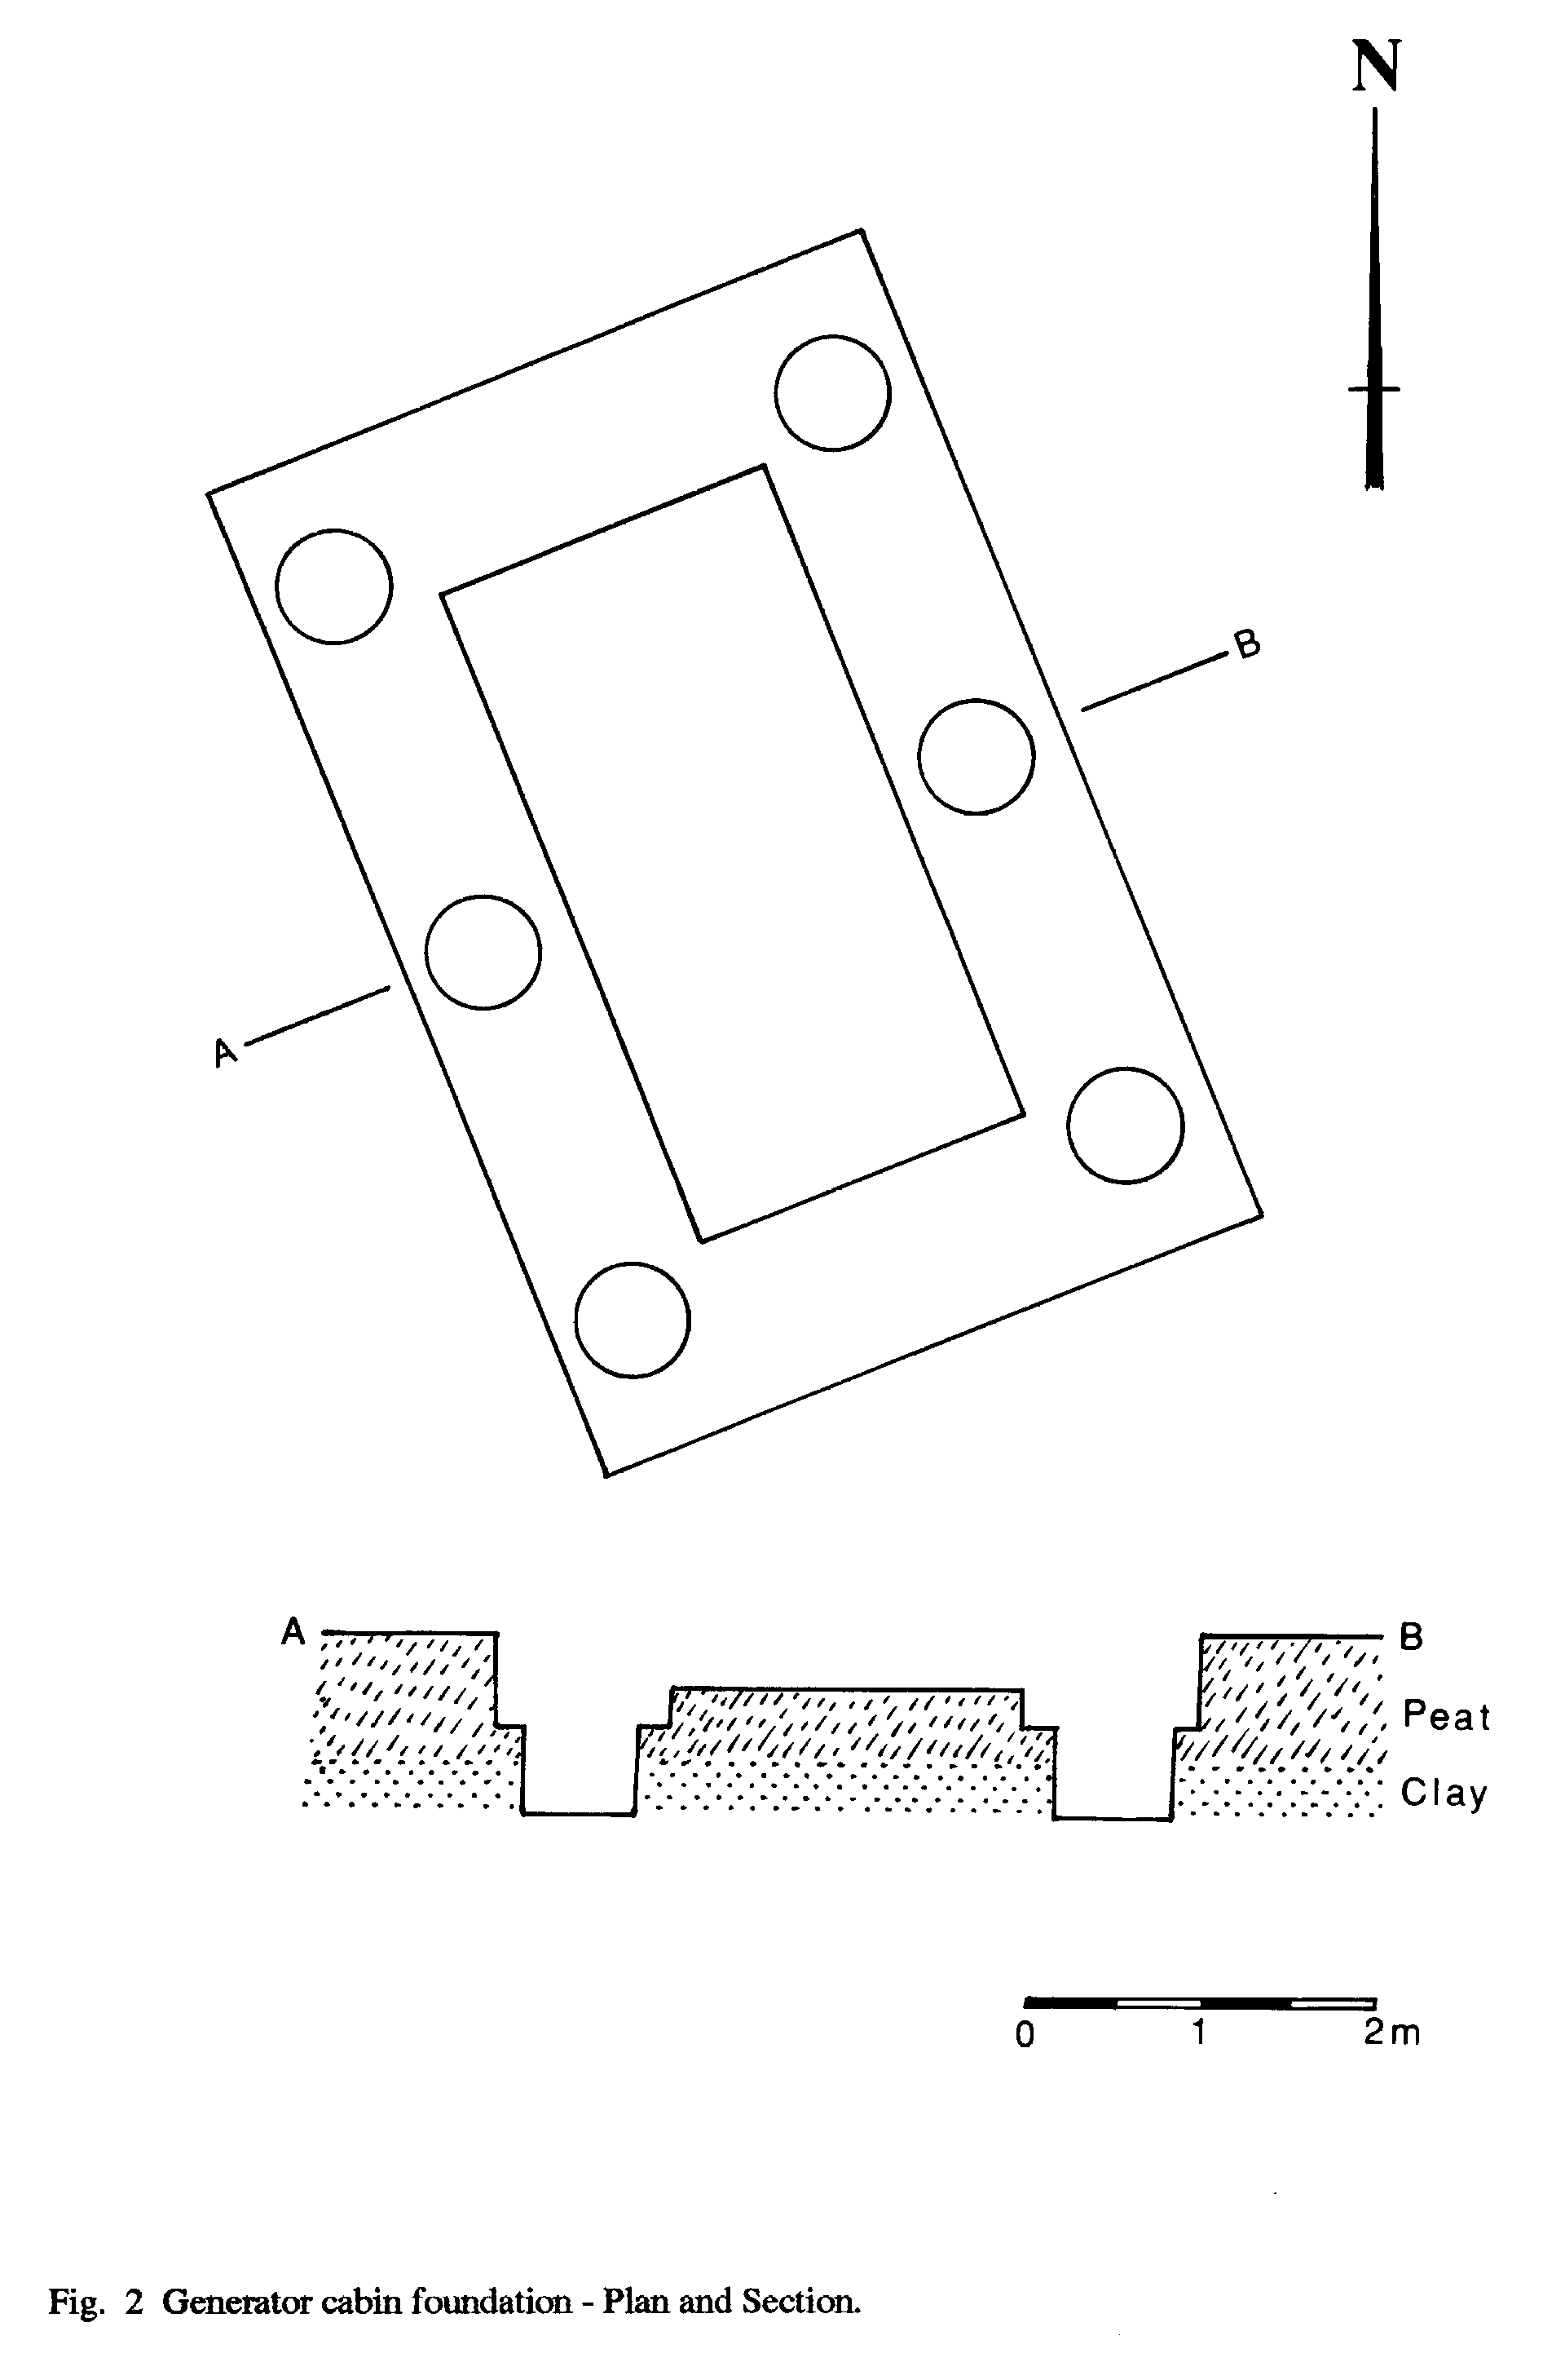

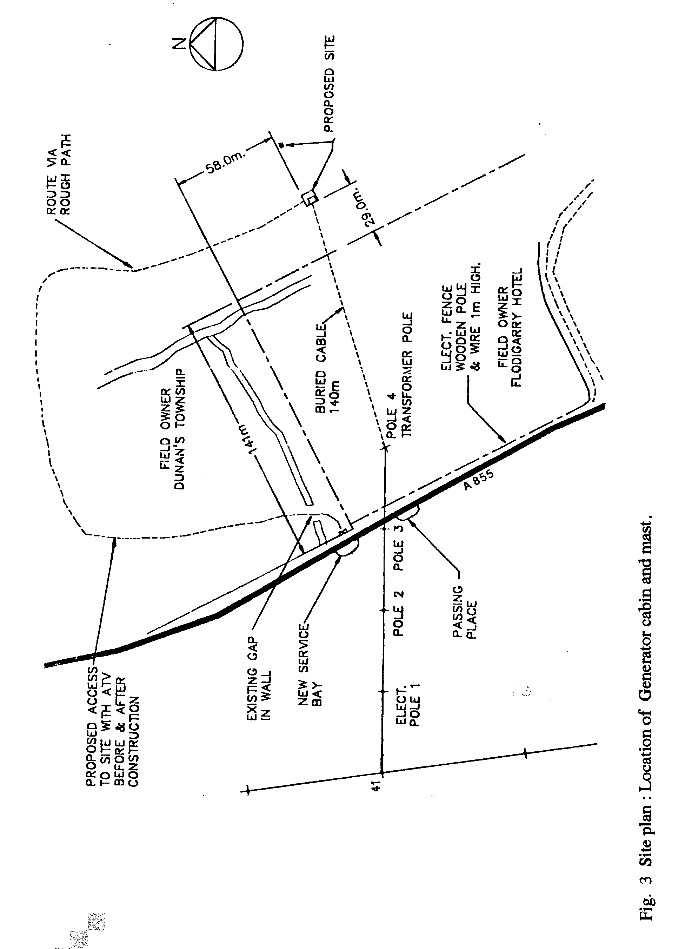

SLIDE INDEX

1. The site from the west

2. The site from the north-west

3. The start of excavations.

- The completed excavations

5. Dun, Druim nan Slochd, from the north.

APPENDIX A

Specification for archaeological watching brief.

APPENDIX B

SMR Cards for

DUN – DRUIM NAN SLOCHD : NG 47SE 7

BROCH – DUN FLODIGARRY : NG 47SE 6

