New House and Access Track at Achpopuli, Abriachan, Inverness-shire

Archaeological Watching Brief

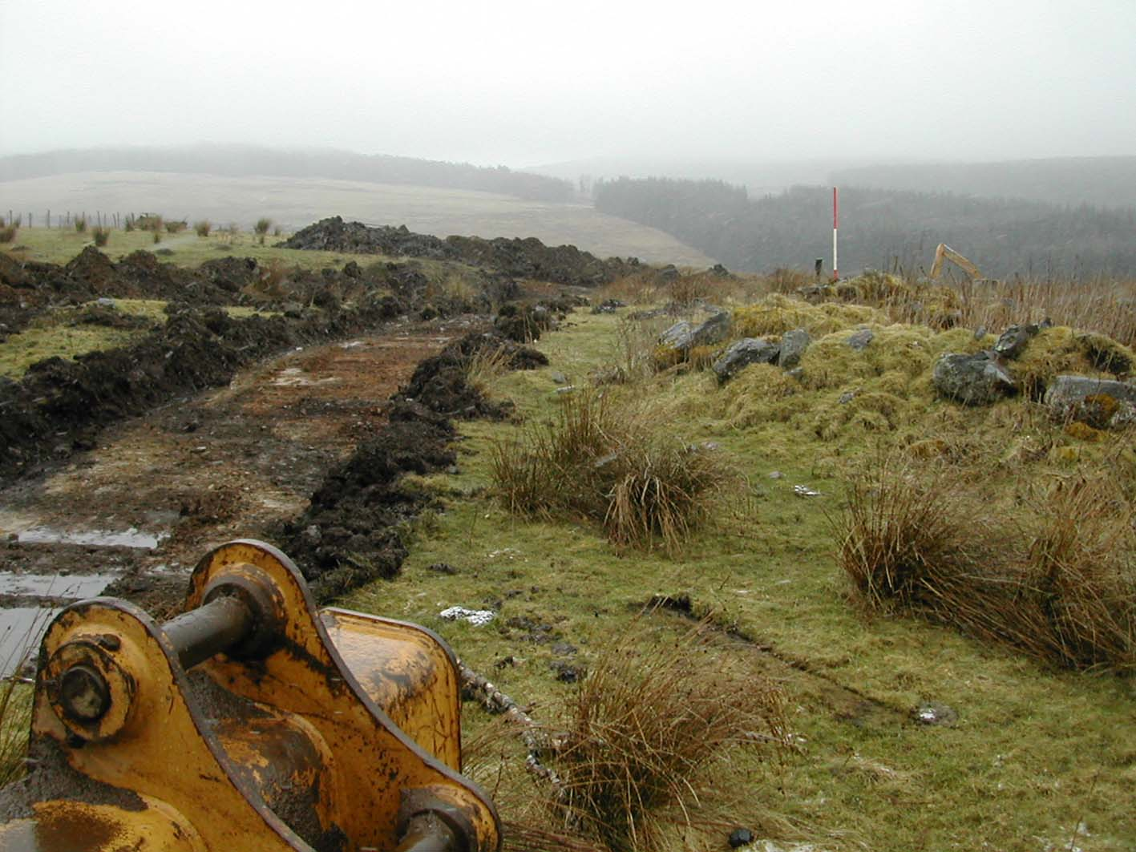

Catherine Dagg

For

Andrew MacMillan
Cragganvallie
Abriachan
Inverness
IV3 8LB

New House and Access Track at Achpopuli, Abriachan, Inverness-shire: Archaeological Watching Brief

- Background

An archaeological watching brief on ground breaking work was required as a condition of planning consent for the following reasons:

This area is considered to be archaeologically sensitive: the application lies in an area where there are known archaeological and historical sites and there is potential for the survival of buried archaeological remains. Specifically, several later prehistoric roundhouses lie within the wider area, one of which is protected as a Scheduled Ancient Monument. There is a potential for buried features to survive within the application site and to be impacted by the proposed development.

An archaeological watching brief is needed at this site because there is a potential for finds or features of interest to be discovered during site works. A watching brief enables any discoveries to be recorded quickly and efficiently as they appear with minimum delay or disruption to the development.

The area to be covered by the watching brief includes two house sites and access roads, together with proposed services, works compounds, borrow pits or other ancillary work. This watching brief, however, covers only the northern of the two house sites and its access track, as the second project will not commence for some months.

- Methodology.

Prior to the watching brief, a desk-based assessment was carried out using all readily available data sources and archive material.

The watching brief was carried out on 29th March 2006, in light snow showers but with reasonable visibility. The site was initially investigated before any work commenced, to check for any visible archaeological features, and standing ruins associated with 19th century settlement were noted and marked to avoid damage. All ground breaking work was monitored.

3.0 Site Description

The small settlement of Achpopuli occupies high, exposed ground rising from the 300m contour on its west boundary to 350m where it is bounded by a track running to the present occupied buildings and south to Drumnadrochit. The site is bounded , apart from to the south, by extensive coniferous plantantions, formerly owned by the Forestry Commission but now owned and managed by the Abriachan Forestry trust, which has opened up the forest and laid out paths and cycle tracks for public amenity.

The ground is improved and under grass although until recently crops have been grown. A small stream runs through the area from E-W, and stones cleared from the fields have been deposited at the stream edge, along with general farm refuse. (Photo no. 1)

The house site occupies a relatively level platform at the western edge of which the ground falls away more steeply to the stream which flows NE to Loch Laide. The access track for this house follows the south side of the small stream, crossing it at two points.

4.0 Archaeological Background

No systematic archaeological survey has been carried out in the area of the proposed development, but a number of prehistoric sites had been noted within the area now under coniferous plantation to the west by 19th century antiquarians and by the Ordnance Survey, who last visited these sites in 1970

The following sites are recorded on the Highland Sites and Monuments Record (SMR)

- Hut Circle, SMR no. NH53SW0012 at NH 5316 3452 an ill-defined hut circle approximately 10m in diameter with around ten stone clearance piles to the SW.
- Druim Ba, Hut Circle, field system, SMR no. NH53SW0011, at NH 5284 3476, Scheduled Ancient monument, SAM index no. 4335
- Allt an Daimh / Rivoulich, cup-marked stone, SMR no. NH53SW0008, at NH 5271 3452. A rough stone with 14 cup marks, at the bottom of a march dyke, on the rough elevated road between Abriachan and Drumnadrochit
- Oval Enclosure, SMR no. NH53SW0035, at NH 5383 4328, as recorded on the 1st edition OS map.

In the general area, a large number of hut circles are recorded to the south, on the high ground above Drumnadrochit, to the west in Glen Convinth and to the north on the high plateau of Caiplich. Neolithic monuments are also represented in these areas by chambered cairns and cup-marked stones.

5.0 Historical Background and Cartographic Evidence

The high ground of Achpopuli is locally thought to have been first colonized, in the modern period, by cleared families. The land, together with the croftlands of Abriachan, were possibly settled by families cleared from glens further west but allowed by Lord Lovat to settle elsewhere on his estate

Achpopuli does not appear on any early maps until the 1st edition Ordnance Survey of 1869. Here one undivided enclosure is recorded, with two roofed buildings and a small garden enclosure south of the small burn, and one unroofed building north of the burn.

By the 2nd edition OS map at the turn of the century, the enclosed area has been divided E-W along the same lines as the present boundaries. The main group south of the burn has altered, with one of the roofed buildings of 1869 now abandoned and two new roofed buildings immediately to the north. The unroofed building north of the burn is still recorded, as is the present farmhouse to the south of the enclosed area. This farmhouse is what is now referred to as Achpopuli.

6.0 Watching Brief

6.1 Building at NH 5362 3446. This building, recorded as unroofed in 1869, stands to a maximum height of 1m and is a substantial visible ruin, although overgrown. It need not be affected by the development of the two house plots and was protected from accidental damage during topsoil stripping of the access track which serves both house sites. It was not investigated in detail, but is probably the earliest building at Achpopuli. (Photos 2 and 3)

6.2 East Stream Crossing At the western stream crossing for the access track, the stream was noted to be running through a deep deposit of peat which has built up within the original v-shaped cut worn by the stream. This peat may represent an original peat layer which covered the entire area before improvements for agriculture in the 19th century. Mixed into this peat layer is material which probably originally lay on its surface but has sunk into the peat through gravity. This material includes plastics and wooden fence posts and is generally the detritus of modern farming. (Photo no. 4)

6.3 Access track through field. The ploughsoil is no deeper than 30-40cm, overlying a compacted rubble-filled subsoil. (Photo no. 5) One stone-lined field drain was noted (Photo no. 6)

6.4 West Stream Crossing. This second stream crossing serves only the northern of the two house sites. At this point the peat fill to the stream bed was less noticeable, but there was a marked increase in the depth of the plough soil where the subsoil representing the original ground profile fell steeply to the stream, indicating that decades of ploughing has pushed the ploughsoil out beyond the field edge.

6.5 House site and area of hardstanding at NH 5352 3451. The house site occupies a featureless grass platform (Photo no. 7) The soil here was markedly more shallow than elsewhere, being no more than 25cm deep (Photo no. 8) and the scars of modern mechanical ploughing were visible in the subsoil.

7.0 Conclusions and Recommendations

No archaeological features were noted during the watching brief with the exception of traces of late 19th-20th century cultivation in the form of field drains and plough marks. The absence of sub-surface features does not in itself indicate an absence of prehistoric or later settlement, merely that any settlement features have been completely removed by subsequent field clearance and ploughing, and did not include such features as pits or foundation trenches which may have survived in the subsoil layer.

No conclusions can be drawn about the presence of any period of settlement to support the known documentary evidence or oral tradition. The ruinous building, recorded in 1869 and surviving as a substantial ruin, is thought to date to a post-Clearance period of settlement on marginal land not previously used for cultivation, unless in the prehistoric period. This can only be substantiated archaeologically by excavation of the extant buildings.

A second watching brief is required for the more southern house site which will not be developed for some months. The negative result of this watching brief reduces the potential for sub-surface archaeological features surviving at that site, and the second watching brief may now be deemed a lower priority.

8.0 Data Sources

The following data sources were consulted during the desk-based assessment:

- Highland Sites and Monuments Record (SMR) held by the Archaeology Unit at Highland Council in Inverness
- National Monuments Record for Scotland (NMRS) held by the RCAHMS in Inverness
- Early maps held by the Map Library within the National Library of Scotland in Edinburgh

9.0 Photographs

Cover: Topsoil stripped route of access track passing the ruinous building (on the right). In the background is Abriachan community woodland and the former cultivated ground of Rivoulich. View from East.

- Edge of E-W running stream, showing field clearance stones deposited at field edge, view from N.
- Ruinous 19th century building, passed by topsoil stripped access track. View from S.
- Ruinous 19th century building, passed by topsoil stripped access track. View from SE.
- Cutting through stream for access track, showing peat layer over which the stream now flows. View from N.
- Topsoil stripped access route, view from W.
- Stone lined field drain within topsoil stripped access track south of stream. View from W.
- Site of house, centre, before groundwork, view from W.
- Section of topsoil at house site, view from E.
- 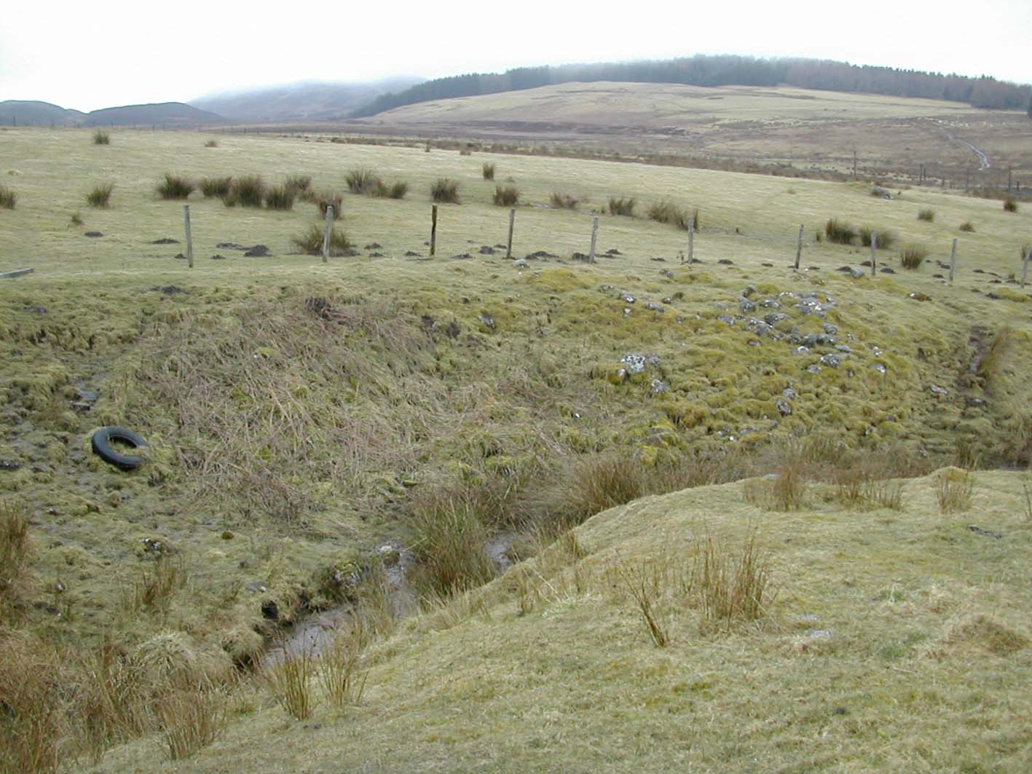

- 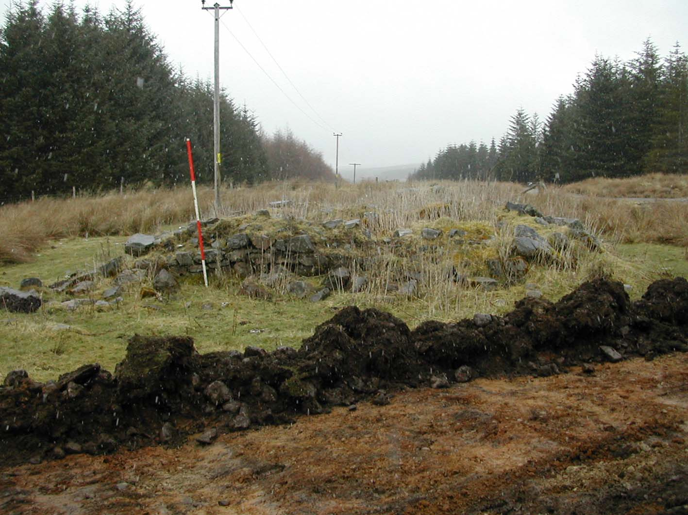

- 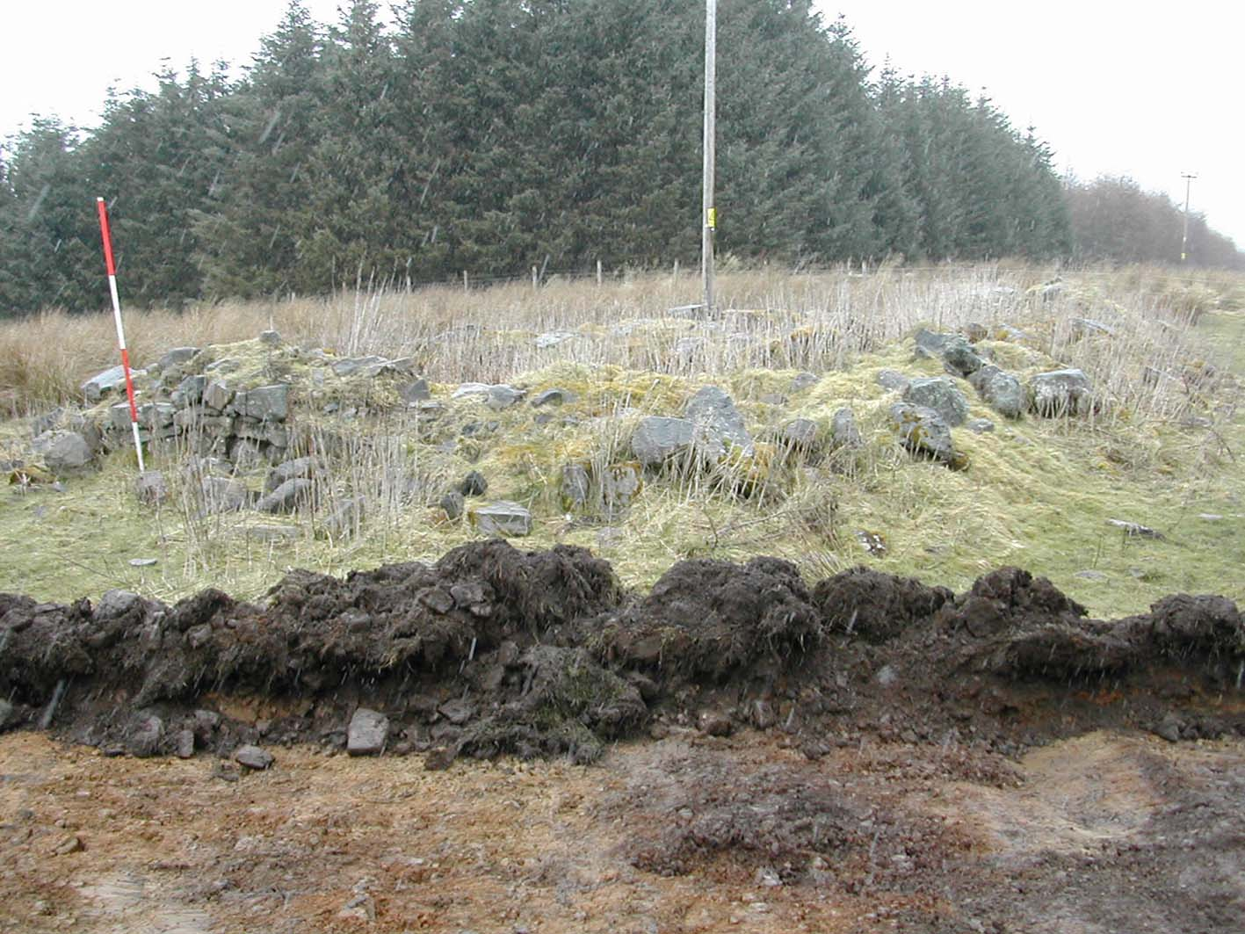

- 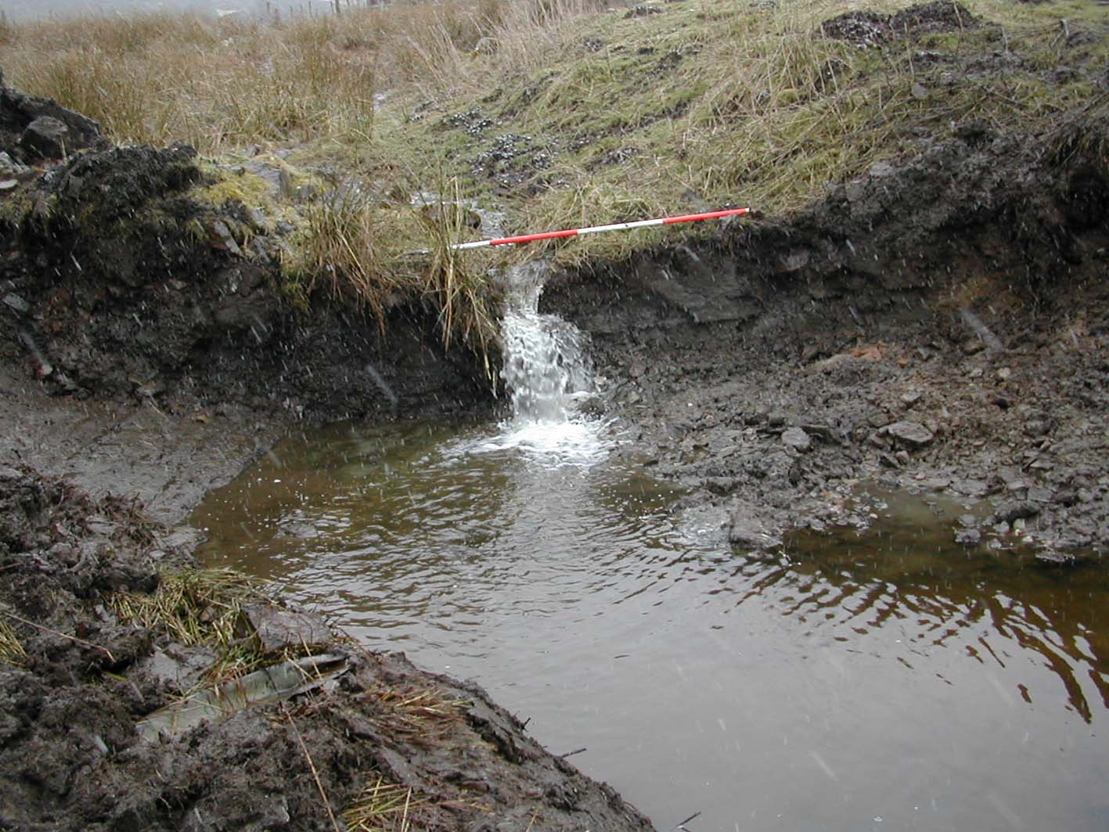

- 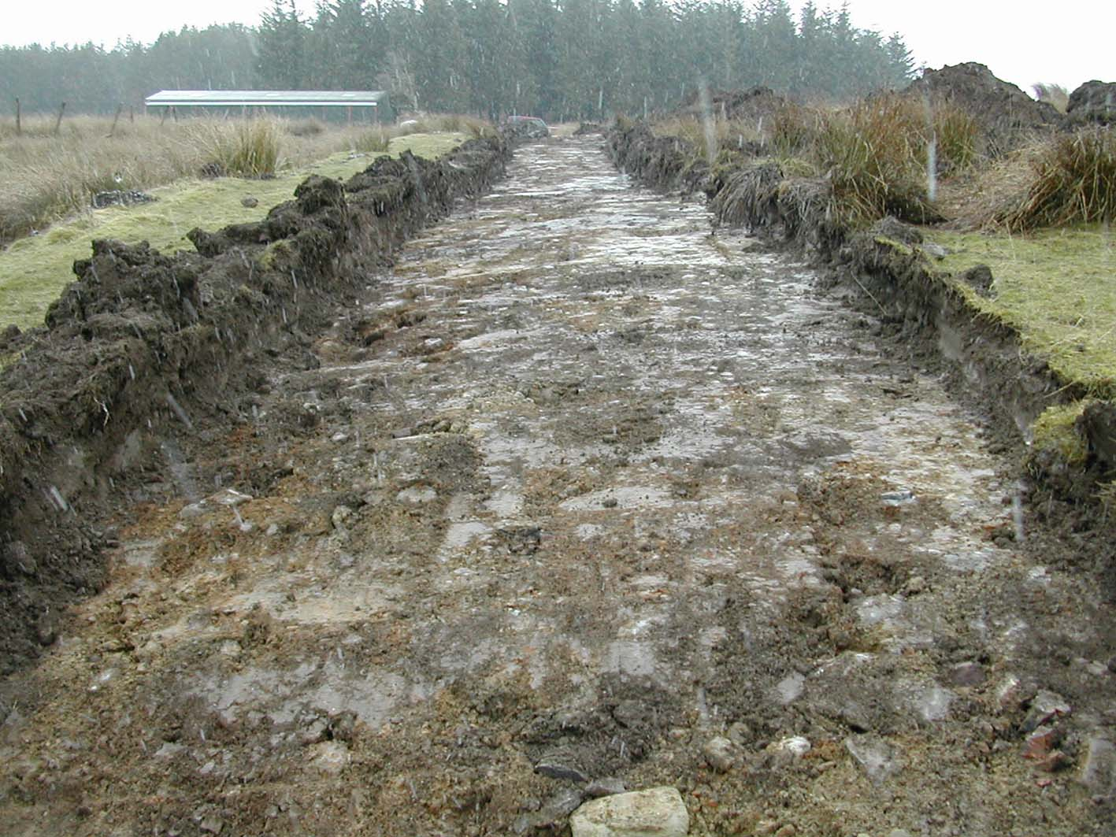

- 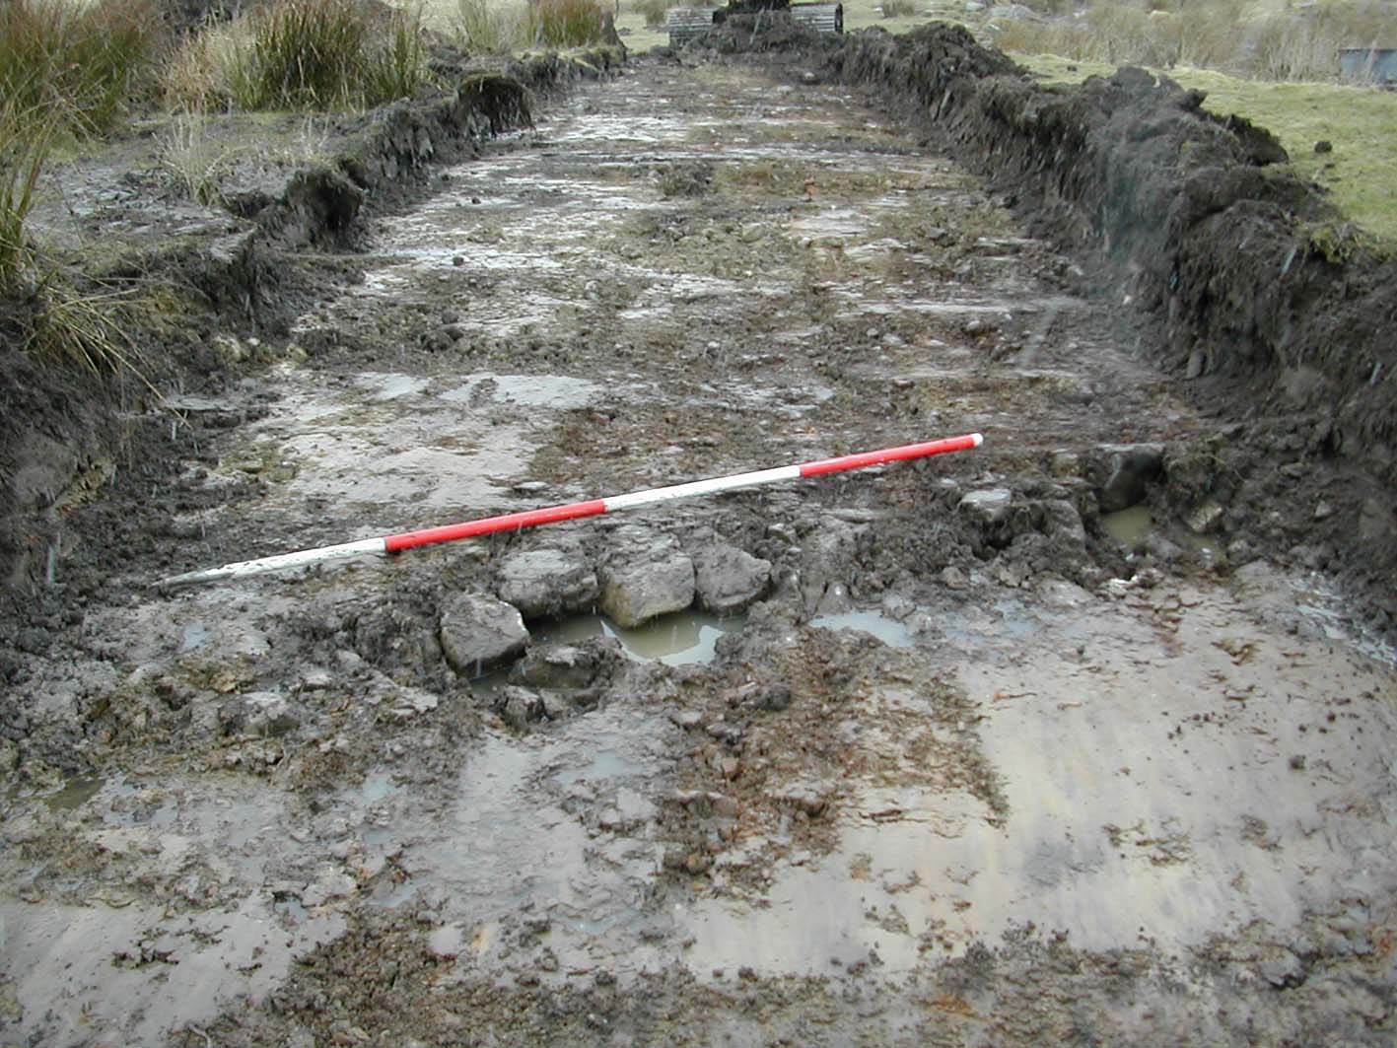

- 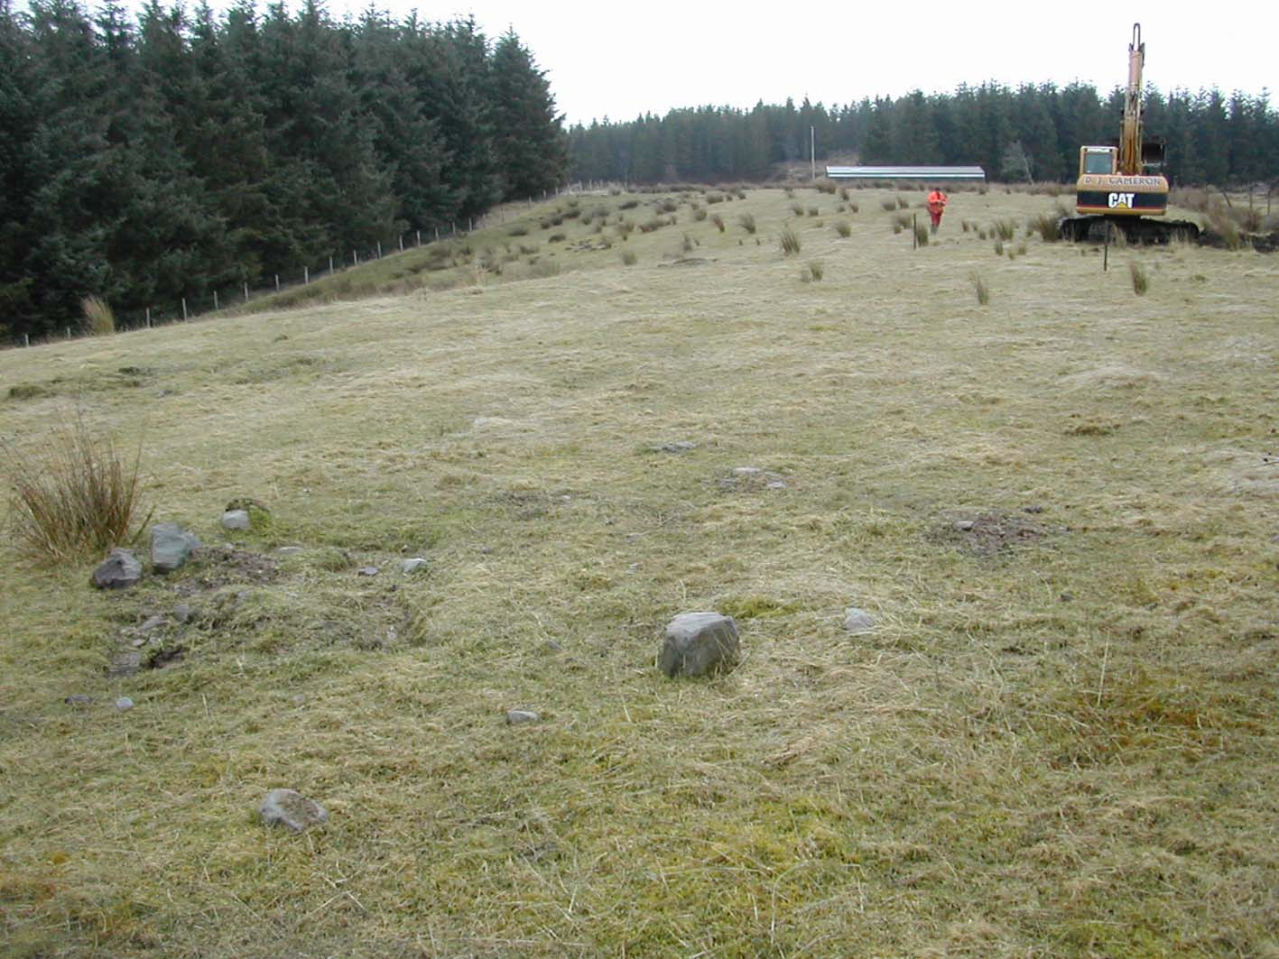

- 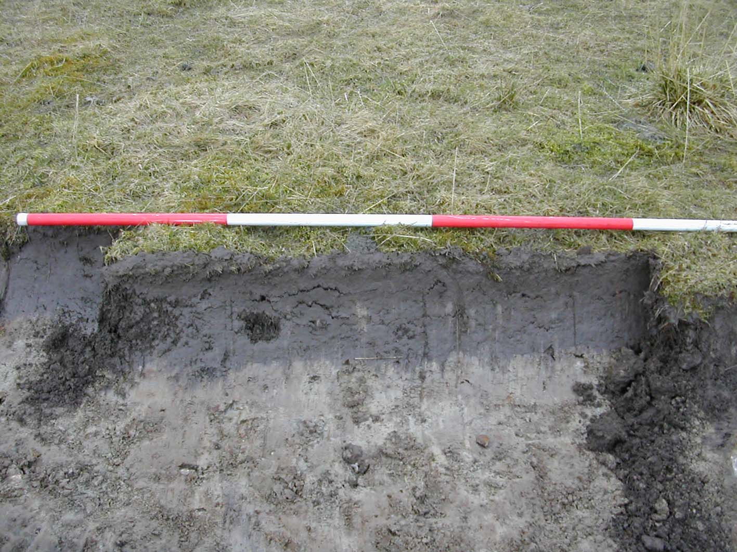

Catherine Dagg, BA, AIFA
2, Ruigh’Riabhach
Scoraig Peninsula
Dundonnell
Wester Ross
IV23 2RE
Tel: 01854 633 337 4.5.06

